**Supplemental Figure S1:**Characterization of RAEC-Exo. RAECs were incubated in basal medium containing 1% exosome-free fetal bovine serum (FBS) for 24h. The medium was collected and subjected to exosome isolation. **A** and **B:** The isolated pellet was examined using NTA to determine exosomal size and concentration. Scatter plot graph of exosomes showing the particle size (nm) versus light intensity of RAEC-Exo and **(A)** the distribution of particle size (nm) versus concentration (particles/ml) of RAEC-Exo **(B)**. Curve 1 described the relationship between particle number and size distribution (concentration/ml; *left Y axis*). Curve 2 describes the correlation between the cumulative percentage distribution of particles (percentile; *right Y* axis) and particle size (x-axis).

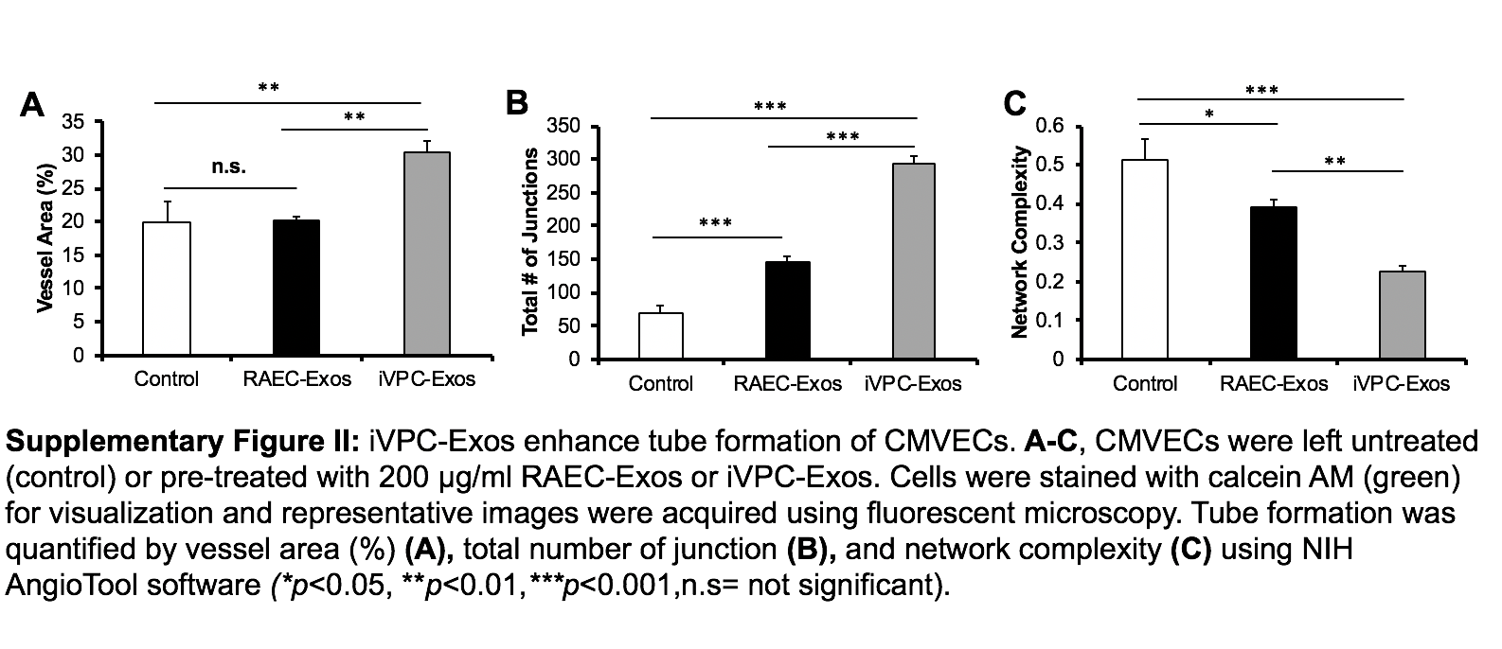

**Supplemental Figure S2:** iVPC-Exos enhance tube formation of CMVECs. **A-C**: CMVECs were left untreated (control) or pre-treated with 200 µg/ml RAEC-Exos or iVPC-Exos. Cells were stained with calcein AM (green) for visualization and representative images were acquired using fluorescent microscopy. Tube formation was quantified by vessel area (%) **(A),** total number of junction **(B),** and network complexity **(C)** using NIH AngioTool software *(*p*<0.05, \*\**p*<0.01,*\*\*\*p*<0.001,n.s= not significant).